Master and slave or Job distributive management

This document explains about master and slave concept. Mainly it is used to share the jobs build load.
How to configure Master and slave configuration:-
- Configuration of SSH between Master and slave:-
- Take two servers let’s say Master and slave
- Go to master server and install Java, Git, Maven & Jenkins.
- Run the Jenkins server on browser.
- Now go to slave server and install Java, Git & Maven
- Now do SSH configuration between Master and slave for that first go to slave server
ssh-keygen -t rsa
- It will generate private and public keys under /root/.ssh/
- Now go to /etc/ssh path and edit the sshd_config file and set the passwordauthentication No to passwordauthentication Yes
- Now restart the sshd service and set the password for root user of slave server
systemctl restart sshd
passwd root
- Now go to Master server run below commands to exchange the ssh keys
ssh root@ipaddress and enter slave’s root user passwoord
- Now Master server will take slave server to Master once it is done SSH configuration has completed.
How to configure Master and slave in Jenkins UI :-
- Now got Master server’s Jenkins UI
- Click on Manage Jenkins -> Manage nodes and clouds
- You can see Master already now we need to add slave server for that inside Manage nodes and clouds -> click on New node
- Give name and select Permanent Agent and click on create.
- After creating node we need to add few details like below.
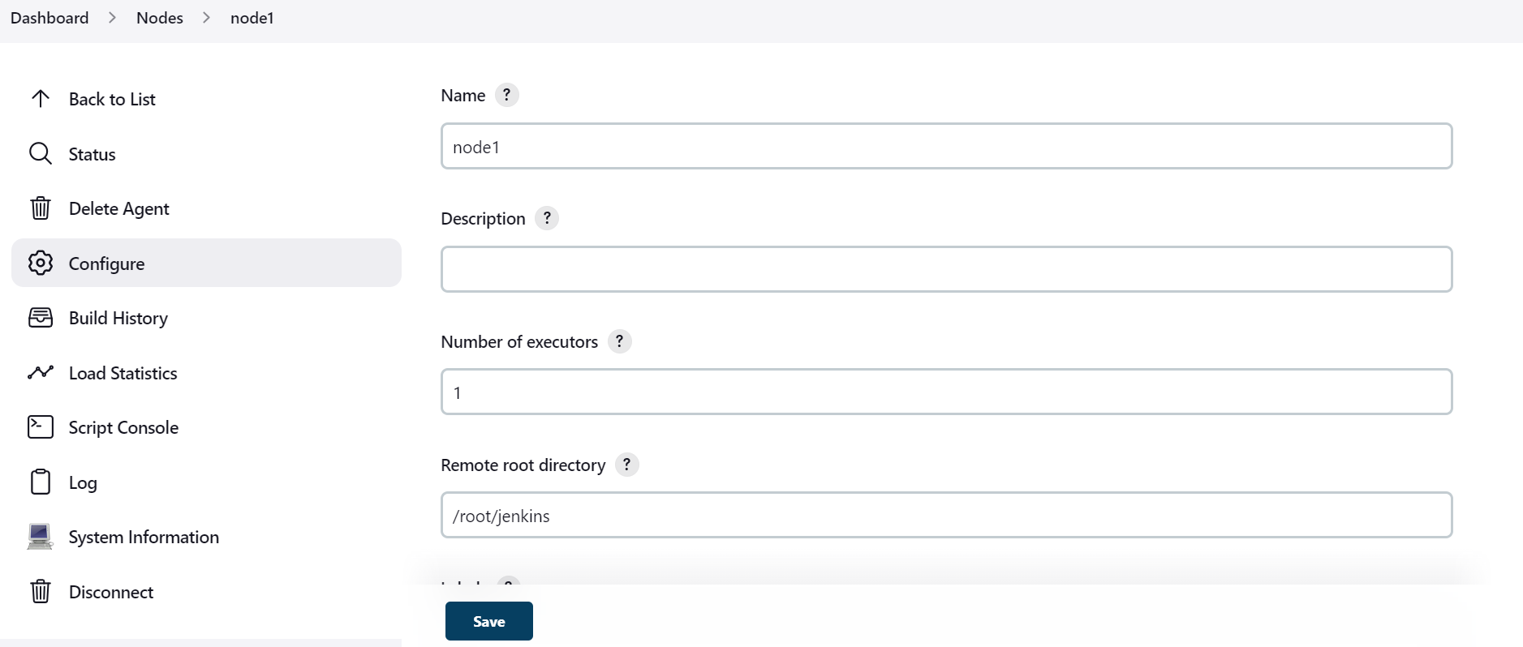
- Remote root directory is the path where we need create Jenkins home folder where you can see workspace.
- Add below details at host add your ip address and root credentials.
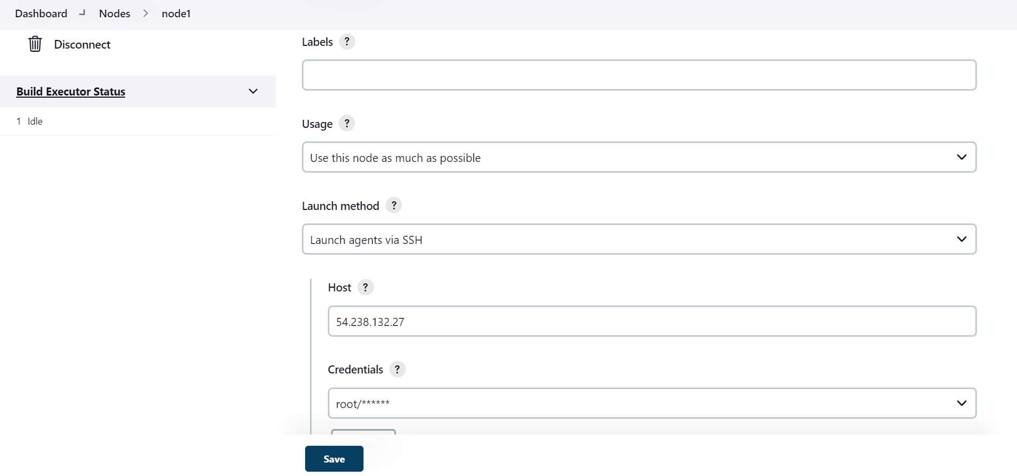
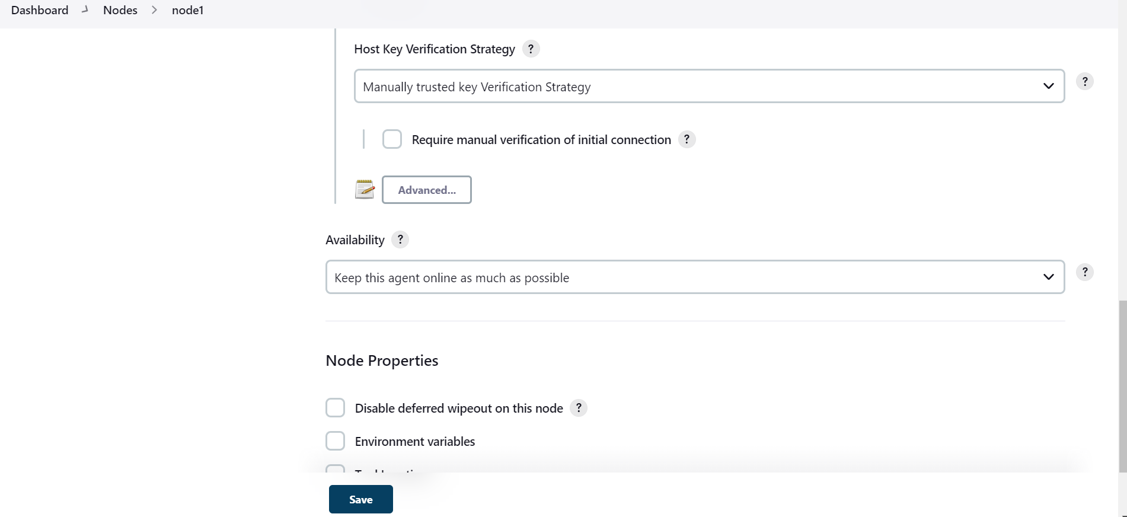
- Save it. Now go to job -> configure –> General. Give check mark where this project can be run and add node name which we created in manage nodes and clouds.
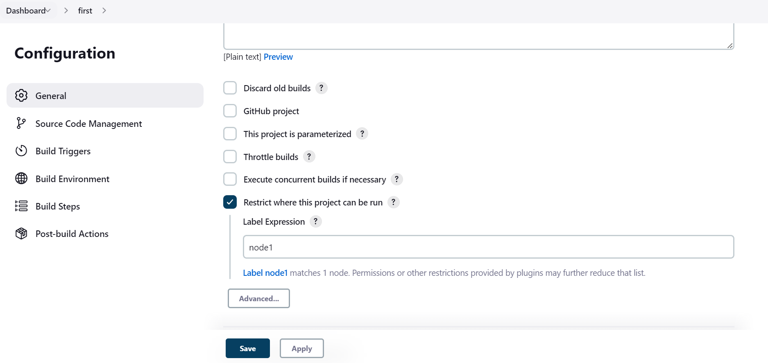
- Configure Git and build steps, save the configuration and trigger the build.
- Now you can see generated artifacts inside /root/Jenkins path on slave.

